Experiment No.6

Title:Shortest Path to other vertices using Dijkstra’s algorithm from a given vertex in weighted connected graph.
Problem:- Urban Traffic Management
Optimizing traffic flow by determining shortest paths for vehicles under varying traffic weights. cive code and its output for this problem
Programm:- #include <stdio.h>
#include <limits.h>
#define V 6 // Number of intersections (vertices)
// Function to find the vertex with minimum distance
int minDistance(int dist[], int visited[]) {
int min = INT_MAX, min_index = -1;
for (int v = 0; v < V; v++) {
if (!visited[v] && dist[v] <= min) {
min = dist[v];
min_index = v;
}
}
return min_index;
}
// Function to print distances
void printSolution(int dist[]) {
printf("Intersection\tShortest Traffic Time from Source\n");
for (int i = 0; i < V; i++)
printf("%d\t\t%d\n", i, dist[i]);
}
// Dijkstra's algorithm
void dijkstra(int graph[V][V], int src) {
int dist[V]; // Shortest distances from source
int visited[V]; // Visited intersections
for (int i = 0; i < V; i++) {
dist[i] = INT_MAX;
visited[i] = 0;
}
dist[src] = 0;
for (int count = 0; count < V - 1; count++) {
int u = minDistance(dist, visited);
visited[u] = 1;
for (int v = 0; v < V; v++) {
if (!visited[v] && graph[u][v] && dist[u] != INT_MAX
&& dist[u] + graph[u][v] < dist[v]) {
dist[v] = dist[u] + graph[u][v];
}
}
}
printSolution(dist);
}
int main() {
// Traffic network graph (weights = traffic time in minutes)
int graph[V][V] = {
{0, 4, 0, 0, 0, 0},
{4, 0, 8, 0, 0, 0},
{0, 8, 0, 7, 0, 4},
{0, 0, 7, 0, 9, 14},
{0, 0, 0, 9, 0, 10},
{0, 0, 4, 14, 10, 0}
};
int source = 0; // Starting intersection
printf("Urban Traffic Management - Shortest Paths from Intersection %d\n", source);
dijkstra(graph, source);
return 0;
}
Output:- 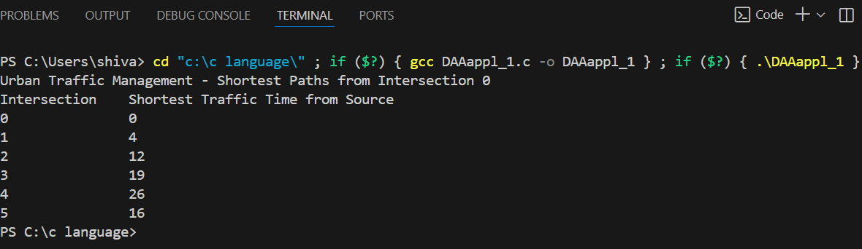
Real-World Applications of Dijkstra’s Algorithm
- GPS Navigation and Route Planning
  - Finding the shortest or fastest route from your location to multiple destinations.
  - Used in Google Maps, Waze, and car navigation systems.
- Telecommunication Networks
  - Determining the least-cost routing of data packets in networks like the Internet.
  - Optimizes latency and bandwidth usage in network routing protocols (e.g., OSPF).
- Transportation and Logistics
  - Calculating minimum travel cost or time for trucks, delivery vans, or public transport.
  - Optimizes routes for supply chains and delivery networks.
- Airline Route Optimization
  - Finding the shortest or least expensive path connecting multiple airports.
  - Useful for minimizing travel time, fuel cost, or layovers.
- Robot Path Planning
  - Enabling robots or drones to move efficiently through weighted grids or maps, avoiding obstacles.
- Urban Traffic Management
  - Optimizing traffic flow by determining shortest paths for vehicles under varying traffic weights.
- Computer Networks
  - Shortest path for message passing in distributed systems.
  - Efficient routing in ad-hoc wireless or sensor networks.
- Game Development
  - Calculating AI character movement on weighted maps for shortest and optimal paths.

